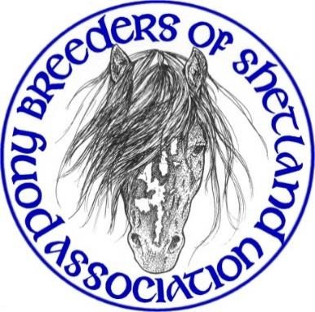
YOUNGSTOCK SHOW
Sunday 15th November 2026
Shetland Rural Centre, Staneyhill, Lerwick
Judging from 10.00am
Affiliated to the Shetland Pony Stud Book Society

Entry fee of £5.00 per pony per class for PBSA members and £8.00 for non-members
Entries accepted NO LATER than Sunday 1st November 2026

Judge: Mr Lee Moulder

SPS-BS BRONZE MEDAL SHOW
Shetland Pony Stud-Book Society Bronze medal will be awarded to the champion pony, subject to the pony being registered with SPS-BS and the owner/exhibitor being a fully paid-up member of the SPS-BS. In the event of the champion pony or owner/exhibitor not being eligible, the Bronze Medal can be awarded to the reserve champion, should they meet the registration and membership requirements. Medals will be awarded by the show secretary, upon production of a current SPS-BS membership card.

SCHEDULE
Class No
1. Young Handler (3 – 9 years)
2. Young Handler (10 – 16 years)
Best Young Handler – 1st placed from classes 1 & 2 to compete.
Ponies in Young Handler classes do not need to be entered in any of the following classes.

3. Miniature Colt Foal 4. Miniature Filly Foal
5. Standard Colt Foal 6. Standard Filly Foal
Best Foal and Reserve – 1st placed from classes 3, 4, 5 & 6 to compete.

7. Miniature Yearling Colt or Gelding (born 2025) 8. Miniature Yearling Filly (born 2025)
9. Standard Yearling Colt or Gelding (born 2025) 10. Standard Yearling Filly (born 2025)
Best Yearling and Reserve – 1st placed from classes 7, 8, 9 & 10 to compete.

11. Miniature 2 yr old Colt or Gelding (born 2024) 12. Miniature 2 yr old Filly (born 2024)
13. Standard 2 yr old Colt or Gelding (born 2024) 14. Standard 2 yr old Filly (born 2024)
Best 2 Year Old and Reserve – 1st placed from classes 11, 12, 13 & 14 to compete.

15. Miniature 3 yr old Colt or Gelding (born 2023) 16. Miniature 3 yr old Filly (born 2023)
17. Standard 3 yr old Colt or Gelding (born 2023) 18. Standard 3 yr old Filly (born 2023)
Best 3 Year Old and Reserve – 1st placed from classes 15, 16, 17 & 18 to compete.

Youngstock Champion & Reserve Champion
To be chosen from 8 ponies – Best Foal, Reserve Best Foal, Best Yearling, Reserve Best Yearling, Best 2 Year Old, Reserve Best 2 Year Old, Best 3 Year Old and Reserve Best 3 Year Old to compete.
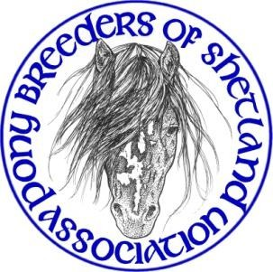
Youngstock Show Rules & Conditions of Entry

Entry fee £5.00 per class PBSA members/ £8.00 non-members Entries accepted NO LATER than Sunday 1st November 2026

General
- The show is affiliated to the Shetland Pony Stud Book Society and is run under their rules. Exhibitors must familiarise themselves with these rules prior to exhibiting.
- All ponies must be registered in the UK Shetland Pony Stud-Book.
- All ponies must be named on the entry form.
- Three-year-old fillies with foals at foot may not be shown.
- All foals must be a minimum of three weeks old on the day of the Show.
- Competing ponies must be the bona-fide property of exhibitors or held on a SPS-BS lease form, and must have been in their possession, on Shetland, for at least four weeks prior to the date of the show. Please ensure all transfers of ownership/lease forms are up to date as entries will be checked against SPS-BS records.
- Owners who have had ponies suffering from an infectious disease within six weeks of the show must not present any ponies for show.
- If any pony is suspected of or found to be suffering from an infectious or contagious disease or any other condition preventing it from being shown it must be removed from the show immediately upon request of the show committee or a vet.
- The Show committee reserves the right to amend, amalgamate, split or cancel any class and to replace a judge if necessary.
- Judging to commence at 10am prompt. Once judging of a class has commenced, no late arrivals will be admitted to the ring.
- After the conclusion of the Championship if the winners of the Best Standard or Best Miniature trophies have not become apparent through the awarding of Champion and Reserve these trophies will be determined from the 1st prize winners from their respective classes.
- Any objection must be made in writing to the Show Committee within one hour of the alleged incident, with a deposit of £20, which will be refunded should the objection be upheld.
- The decision of the Judge and the Show Committee is final.

Exhibitors
- Exhibitors’ numbers will be available from the Secretary and the correct number must be displayed on the handler at all times.
- Whips/show canes carried must not exceed 30” in length.
- All children under the age of 16 years must wear a hard hat while exhibiting.
- Entire males aged 2 years and over must be shown bitted and it is advised that they display a stallion badge on their bridle.
- No child under 14 years may be in charge of an entire male (excluding foals) in the ring.
- There must be no colts or stallions in Young Handler classes.
- Young Handlers must be a minimum of 3 years of age on the day of the show.
- Exhibitors must not kneel but remain standing at all times whilst in the ring.
- It is the responsibility of each exhibitor/competitor to ensure that the ring, surrounding area and car park are left clean and tidy at the end of the show.
Neither the PBSA Youngstock Show nor its organisers will be held liable for anything that may happen from any cause or circumstance whatsoever to any person, animal, article property. It is a condition of entry that each exhibitor/competitor shall indemnify the show against any such matter aforesaid when signing the entry form. By signing the entry form exhibitors agree to abide by the rules, code of conduct and procedures of the Pony Breeders of Shetland Association.

PBSA Youngstock Show 2026 Entry Form

Entry Fees £5.00 per class for PBSA members/£8.00 per class for non-members Closing date for entries Sunday 1st November 2026, no late entries accepted

Class sponsorship would be greatly appreciated at £15 per class. Please make 3 choices below as your first choice may not be available.
1. 2. 3.

Cat No | Class No. | Standard/  Miniature | Name of Pony | Stud Book  No. | Entry Fee
Forms Should Be Returned To:  Arianne Sandison  29 Blydoit Park  Scalloway  ZE1 0UG  Tel: 07551 981627  Email: arianne.charlotte@hotmail.co.uk Cheques Made Payable to: Pony Breeders of Shetland Association  Bank Details available on request |  |  | Name (to be displayed in catalogue): Address:  Email: Tel: | Entry Fees
 |  |  | Name (to be displayed in catalogue): Address:  Email: Tel: | Sponsorship
 |  |  | Name (to be displayed in catalogue): Address:  Email: Tel: | Prepaid Catalogue (Tick if required) | £3.00
 |  |  | Name (to be displayed in catalogue): Address:  Email: Tel: | Total:

Neither the PBSA Youngstock Show nor its organizers will be held liable for anything that may happen from any cause or circumstance whatsoever to any person, animal, article property. It is a condition of entry that each exhibitor/competitor shall indemnify the show against any such matter aforesaid when signing this entry form. By signing this entry form exhibitors agree to abide by the rules, code of conduct and procedures of the Pony Breeders of Shetland Association.

Signature: Date:

