PBSA Membership Form
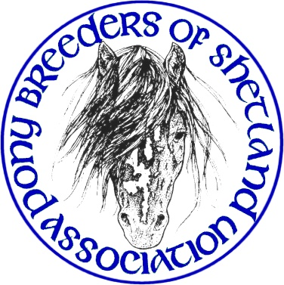

The Pony Breeders of Shetland Association (PBSA) invite you to become a member of the Association for 2017

The subscription fees for year 1 January 2016 - 31 December 2016 are:
Standard Associate
Adult £20.00 £15.00
Junior (15 years and under) £7.50
Joint Membership £35.00 £25.00
Family Membership £40.00 £30.00
Please complete the form below and return with the appropriate fee to the PBSA secretary at the address below.
Rosemary Cross, Secretary, PBSA, Kulladale, Papil, Bridge End, Burra, Shetland, ZE2 9UY.

Name:
Address:
 |  |  | Postcode:
Tel: |  |  | Mobile:
e-mail:
Stud Name:
Membership Type (choose one only):
Adult* |  | Junior** |  |  | Family***
Adult Associate* |  | Joint**** |  |  | Family Associate***
Names of Additional Family Members
*Adult members are those aged 16 years and above. **Junior members are those aged 15 years and under. *** A Family membership may consist of junior members with a maximum of 2 adults
****Joint membership is for two adults living at the same address
By completing and submitting this form you are deemed to agree to be bound by the terms and conditions of the PBSA as laid down in its Constitution, a copy of which is available to view on the website.
1. Membership of The Pony Breeders of Shetland Association (PBSA) shall be at the discretion of the PBSA Committee.
2. Subscriptions are due on 1st January and if not paid by the following 31st March, they shall be held to be in arrears. THANK YOU FOR YOUR SUPPORT!

